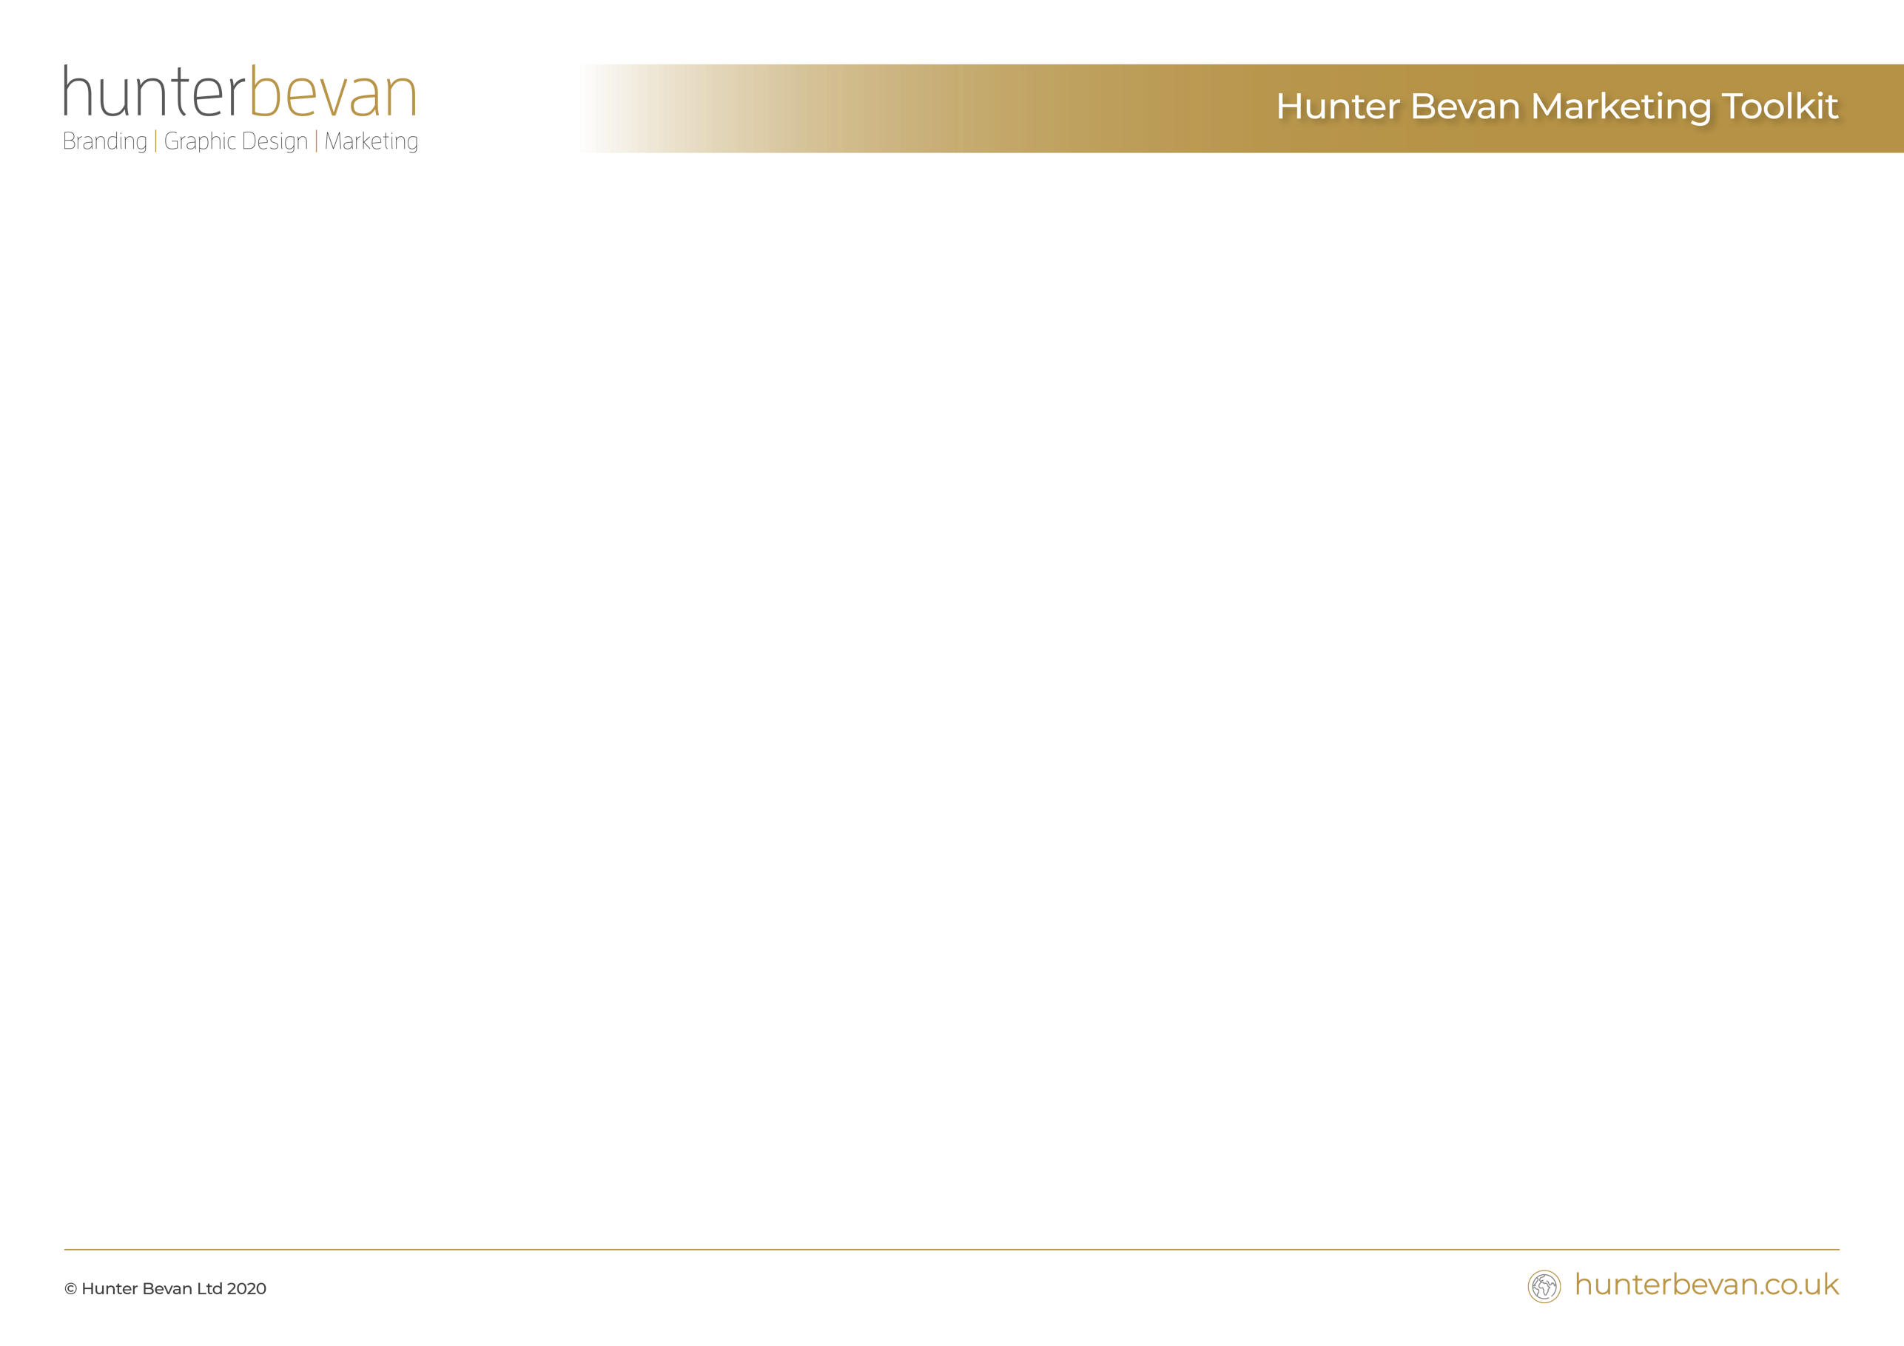

As a Business - Where are we now?

What are we doing well? ​ | What can we improve on? | What can we avoid? | What gaps can we fill?

What are our key products/services?

​What are our ‘best selling’ products/services? | What are our ‘least popular’ products/services? | What’s profitable,  and what’s not? | What new products/services could we develop?

Who are our core customers?

​Do we want more of the same? | Who else can we look for? | Where can we look for them? | What do our customers really want from us?

Who are our competitors?

​Who are we fighting with for market share? | How is our product/service different from the competition? | If no different, how as a business are we different? | What do we do best?

Where do we want to be in 12 months from now?

​Do we want more of the same customers/clients? | Do we want more from existing customers/clients? | Do we want to reconnect with past customer/clients? | Do we want to find new areas of business?

As a business – How do we get there?

​How can we achieve this? | What resources do we have? | What can we put in place to keep existing customers/clients? | What can we do to attract new customers/clients?

